Assignment 2

1:Write a program that accepts numbers continuously as long as the number is positive and prints the sum of the given numbers.

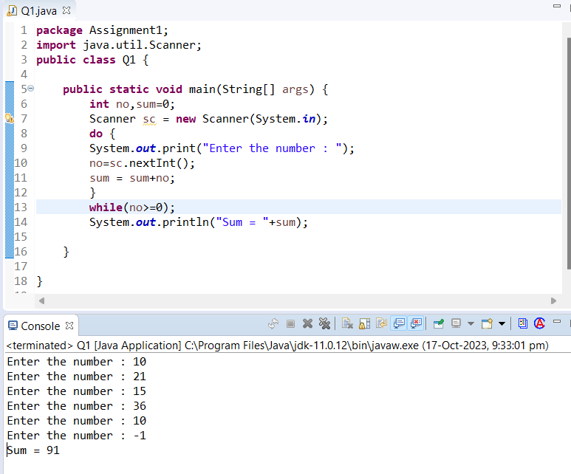

--------------------------------------------------------------------------------------------------------------------------------------

2. Write a program to accept two integers x and n and compute x raised to n.

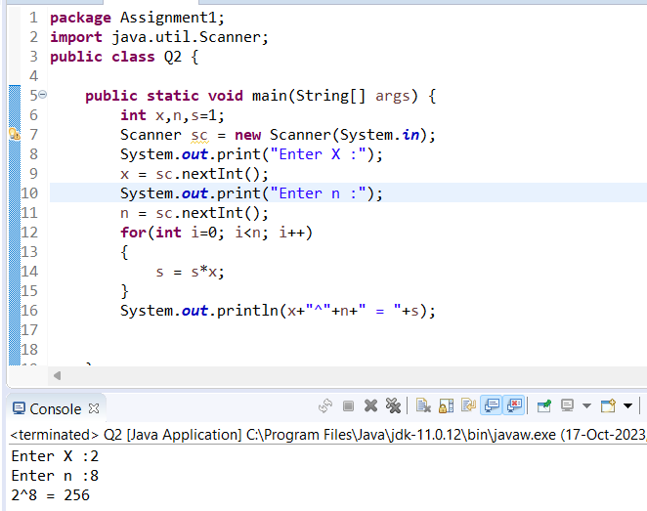

--------------------------------------------------------------------------------------------------------------------------------------

3. Write a program to accept a character, an integer n and display the next n characters.

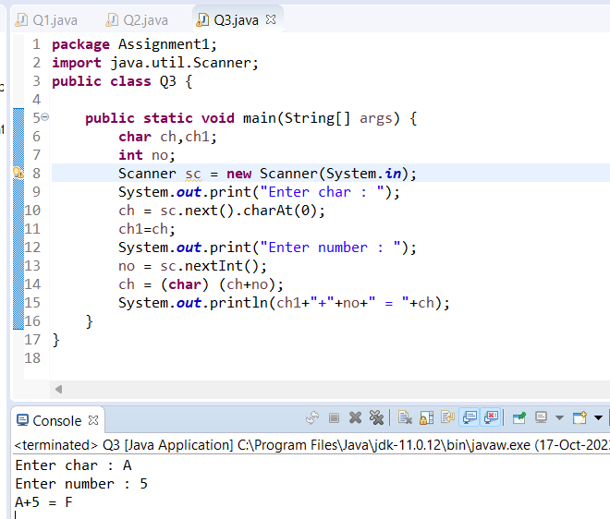

--------------------------------------------------------------------------------------------------------------------------------------

4. Write a program to calculate factorial of a number.

For e.g. factorial of 5 = 5! = 5 \*4\*3\*2\*1 = 120

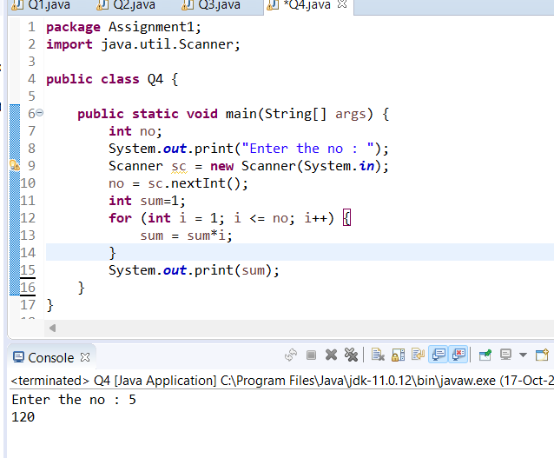

-------------------------------------------------------------------------------------------------------------------------------------

5. Write a program to calculate factors of a given number.

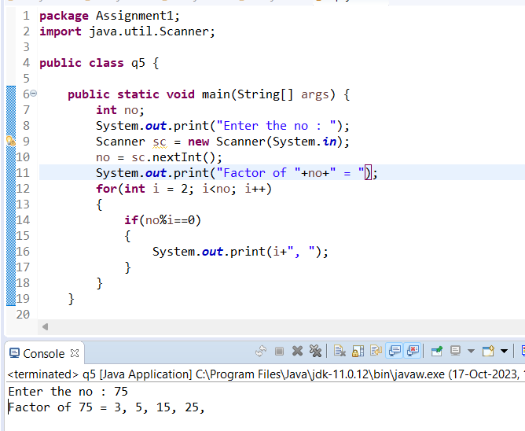

--------------------------------------------------------------------------------------------------------------------------------------

6. Accept two numbers and calculate GCD of them.

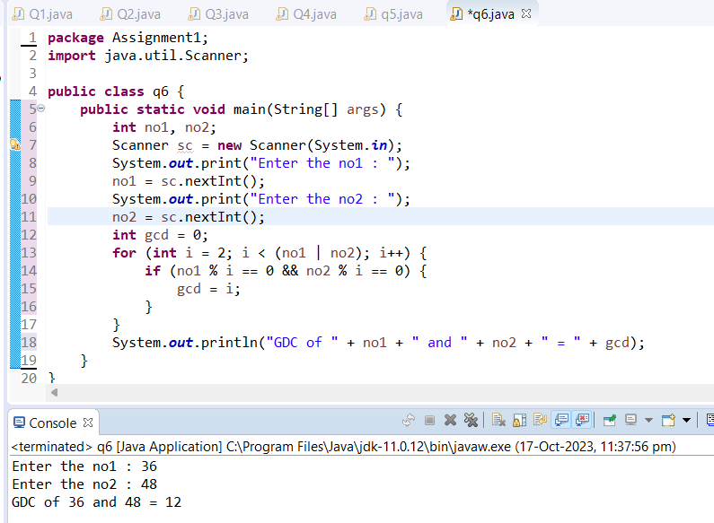

-------------------------------------------------------------------------------------------------------------------------------------

7. Write a menu driven program to do following operations :

a) Compute area of circle

b) Compute area of rectangle

c) Compute area of triangle

d) Exit

Display menu, ask choice to the user, depending on choice accept the parameters and perform the

operation. Continue this process until user selects exit option.

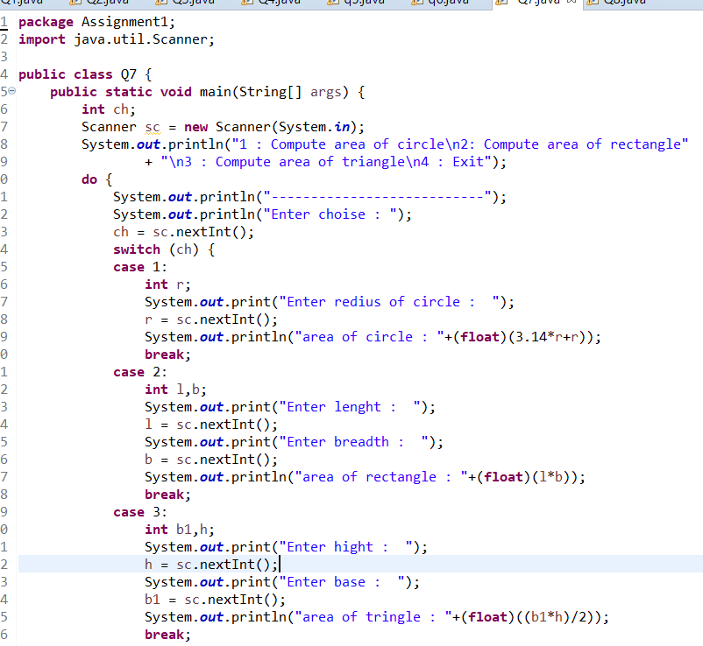

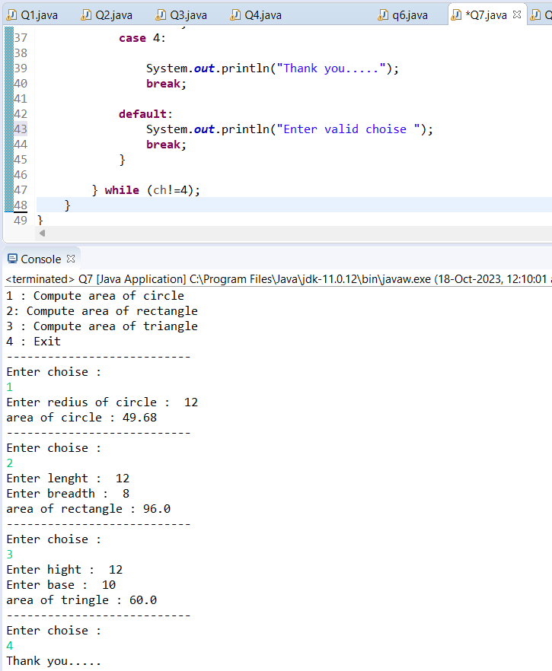

--------------------------------------------------------------------------------------------------------------------------------------

8. Write a program to print all prime numbers between 1 to n

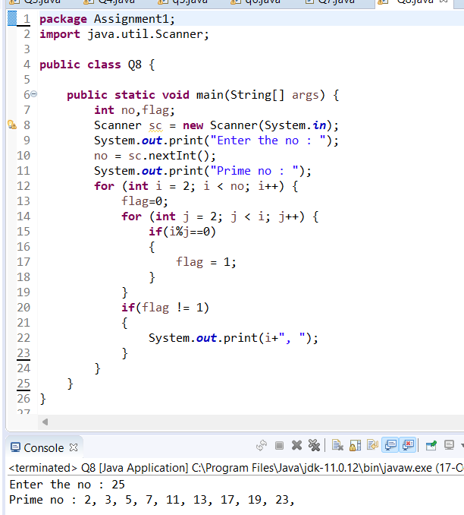

--------------------------------------------------------------------------------------------------------------------------------------

Lab 3

1:Create MathOperation class,create overloaded add method for accepting different data type and show addition (use:Function Overloading)

Write method accepting variable arguments of type int and show sum of all elements(use:varargs)

Create tester class and call methods from MathOperation class.

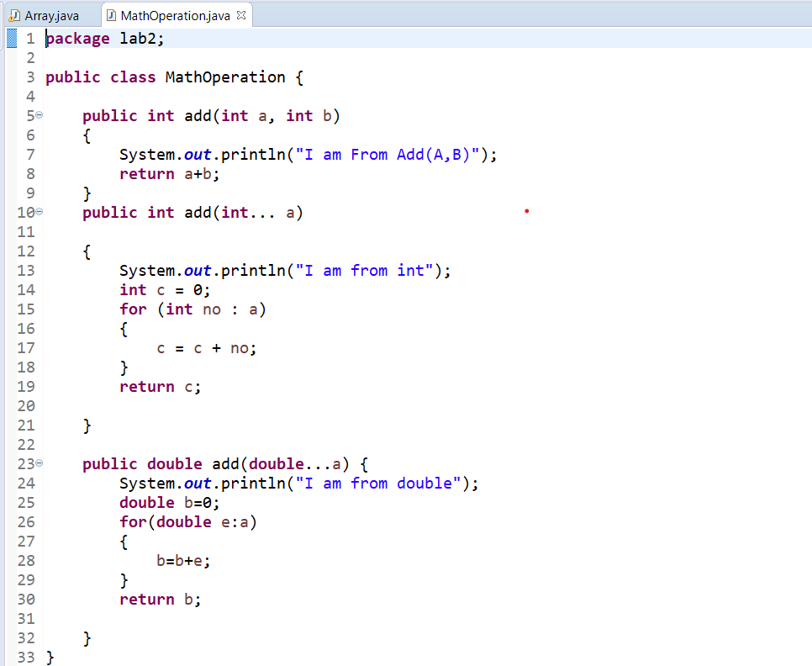

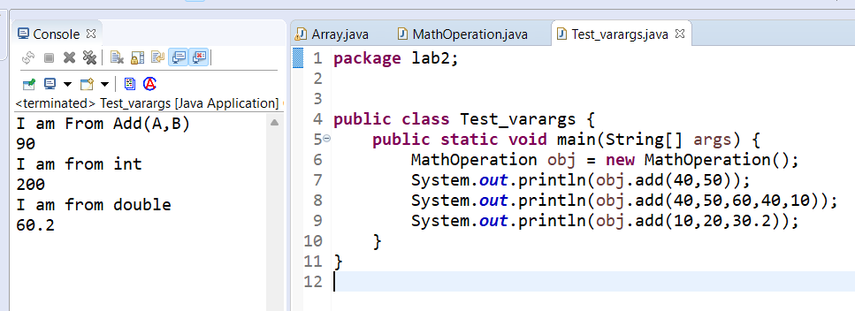

--------------------------------------------------------------------------------------------------------------------------------------

2:Create a menu driven program for performing operations on array;

1:Show Array

2:Add element

3:search element

4:doubleArrayElement

5:sortArray

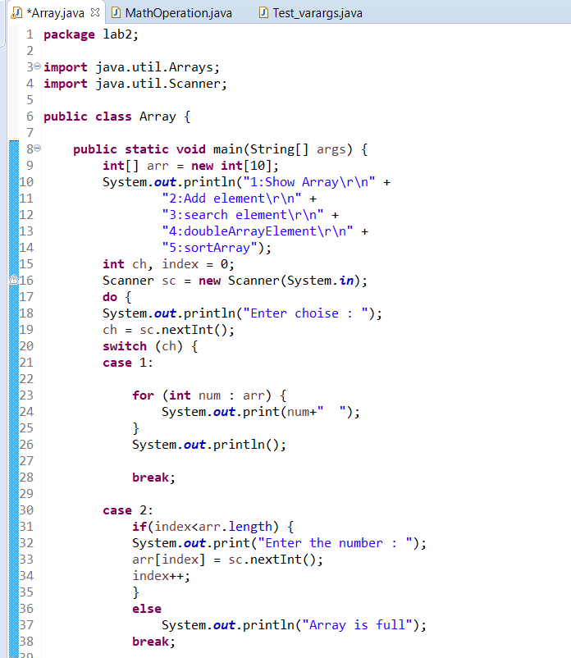

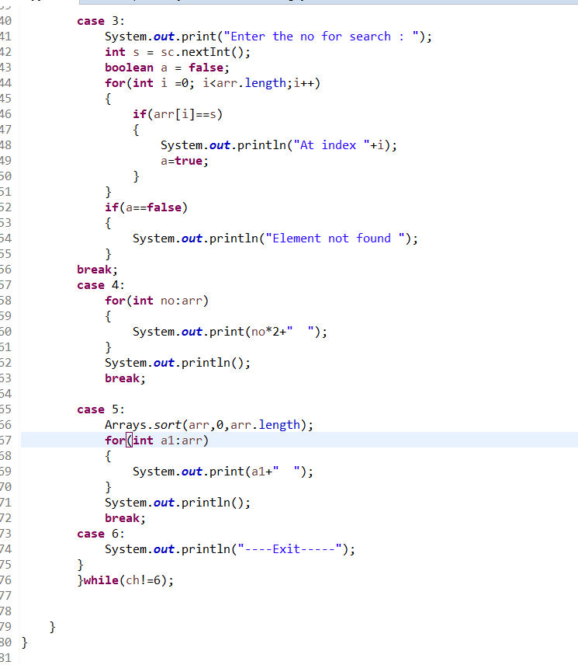

--------------------------------------------------------------------------------------------------------------------------------------

2:Create Date Class with Data Members day,month, year

2.1:Create an object and initialize it using setDate methods and display it using

displayDate methods.

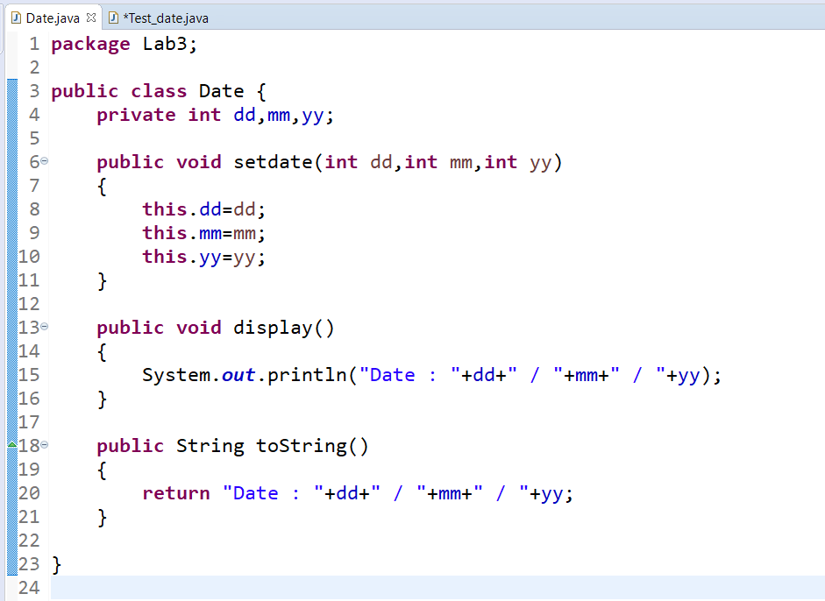

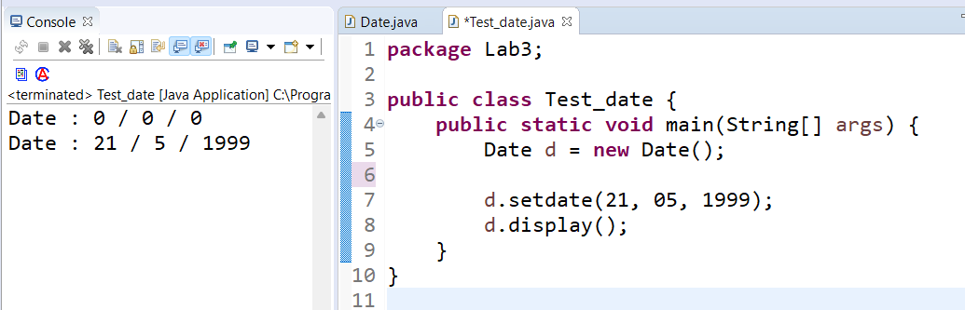

--------------------------------------------------------------------------------------------------------------------------------------

3:Create Student Class with RollNo,name,totalMarks and Grade

.Create an object and initialize it using assignStud method and print it using

printStud method. Create Object of the student and call Methods

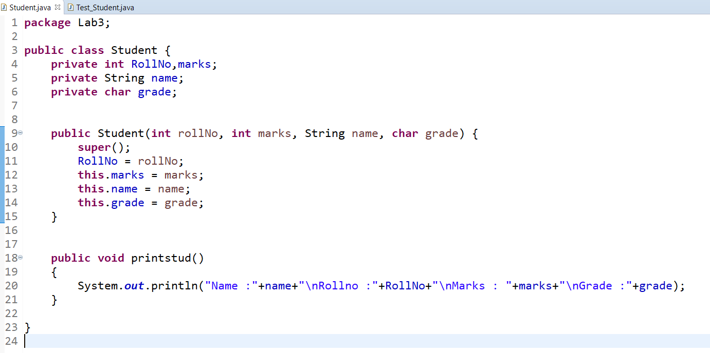

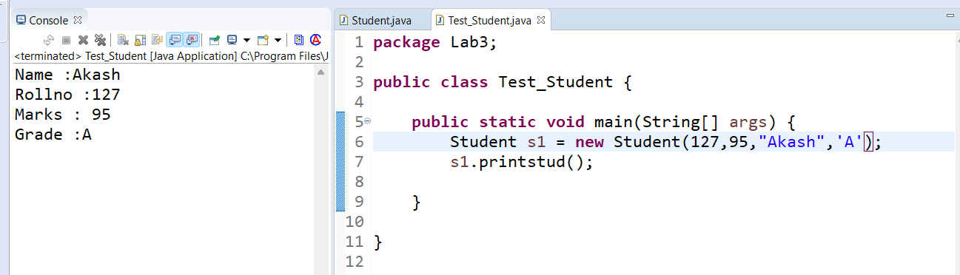

-------------------------------------------------------------------------------------------------------------------------------------

4:Create java application for bank account handling.

4.1. Create a class BankAccount -- acct no(int),customer name(string),balance(double)

constr to accept all details

4.2 Add Business logic methods

Methods

public void withdraw(double amt)

public void deposit(double amt)

4.3:Create TestAccount class...Create object of account class and test withdraw and deposit methods.

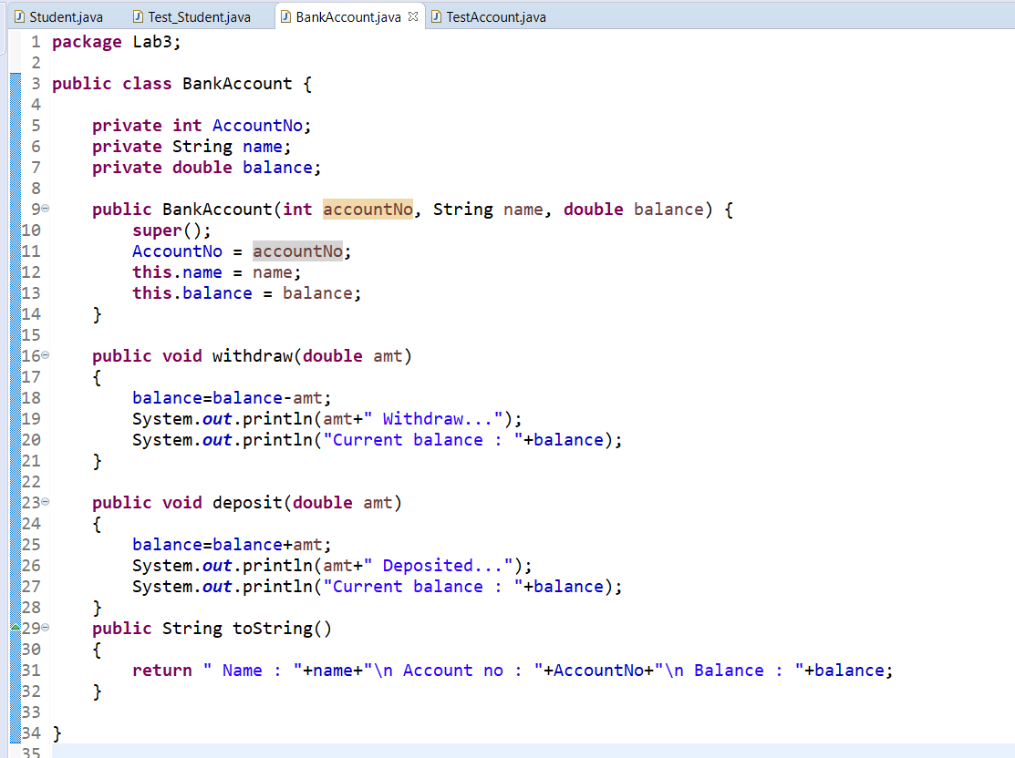

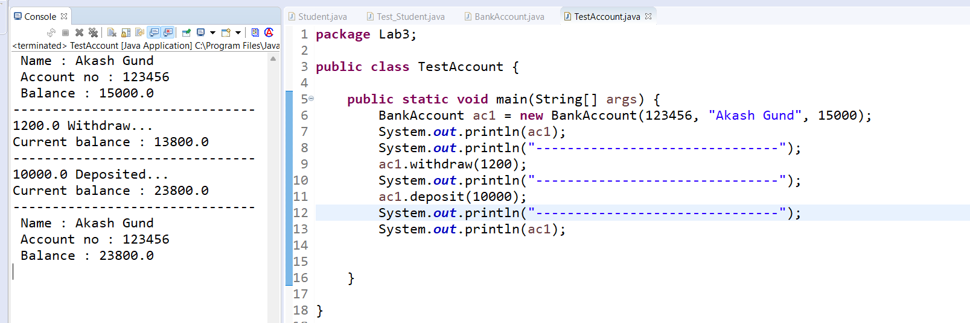

--------------------------------------------------------------------------------------------------------------------------------------

Lab 3.1

1:Write a program to create student class with data members rollno, marks1,mark2,mark3.

Accept data (acceptInfo()) and display using display member function.

Also display total,percentage and grade.

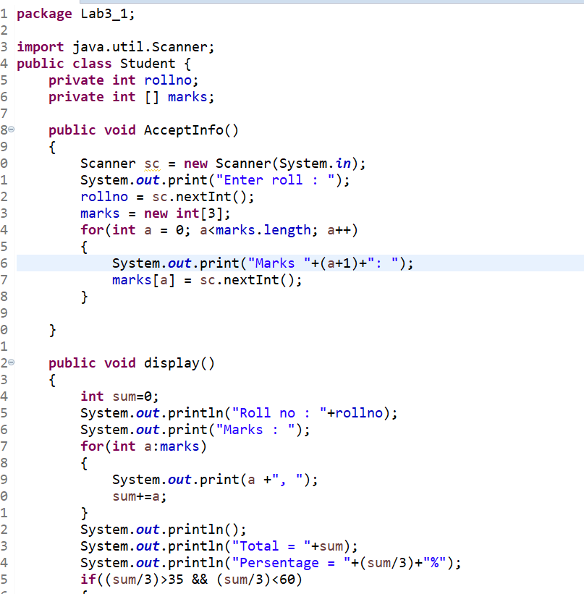

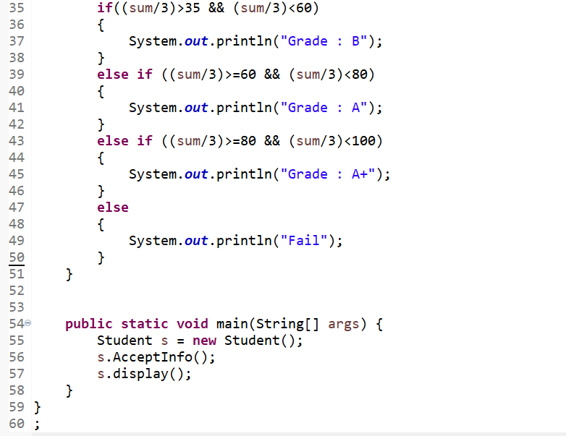

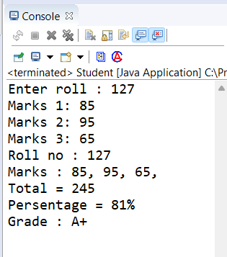

1. Create a class Person with data members as name, age, city. Write getters and setters for all the data

members. Also add the display function. Create Default and Parameterized constructors. Create the

object of this class in main method and invoke all the methods in that class.

0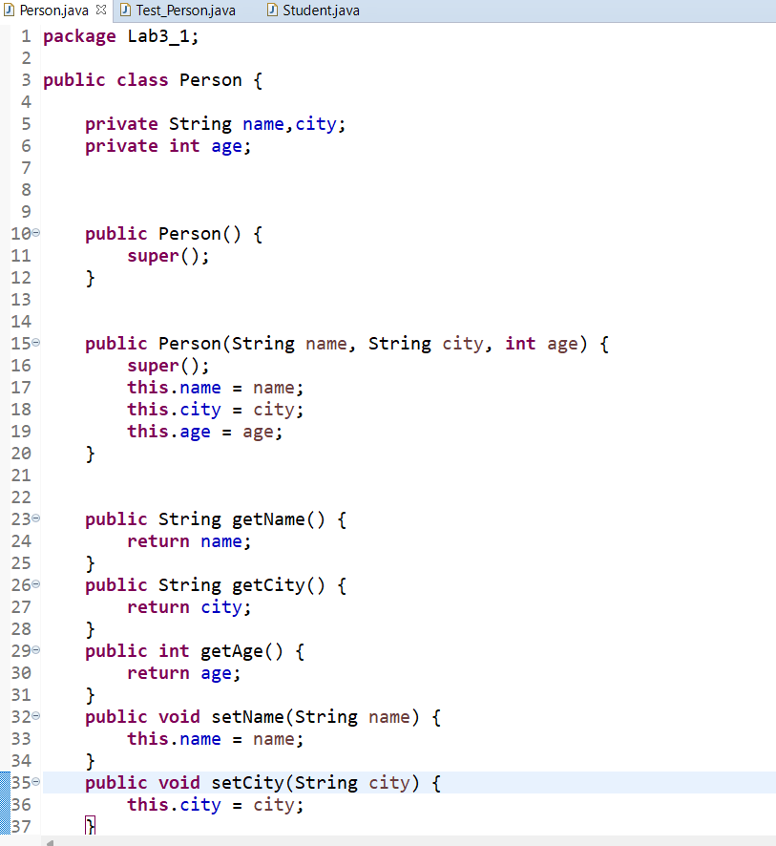

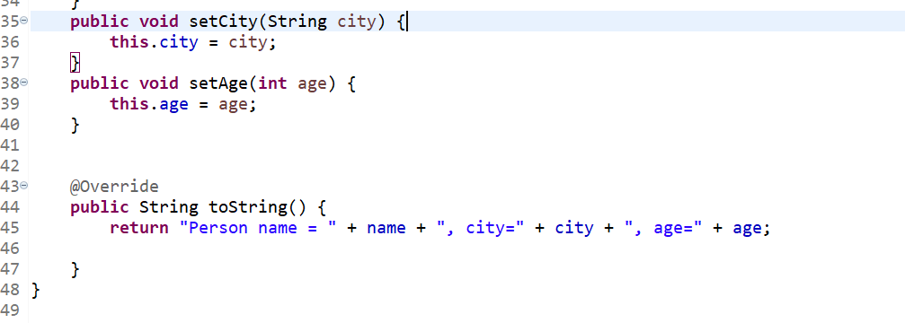

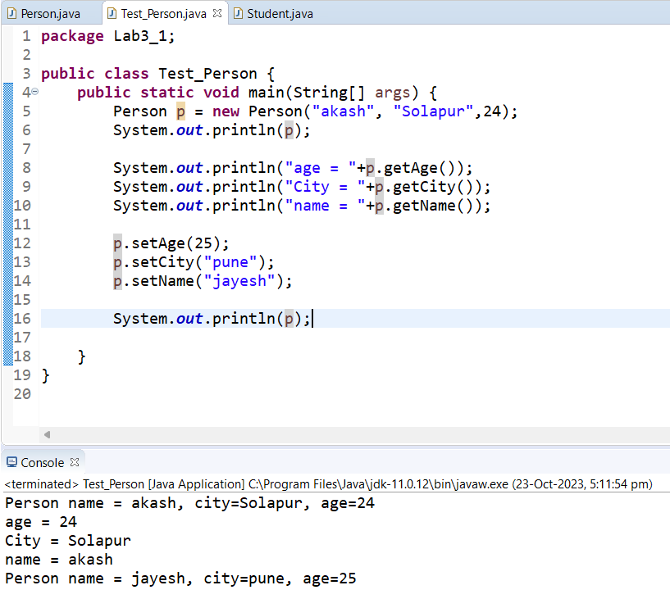

2. Create a class Date with data members as dd, mm, yy. Write getters and setters for all the data members. Also add the display function. Create Default and Parameterized constructors. Create the

object of this class in main method and invoke all the methods in that class.

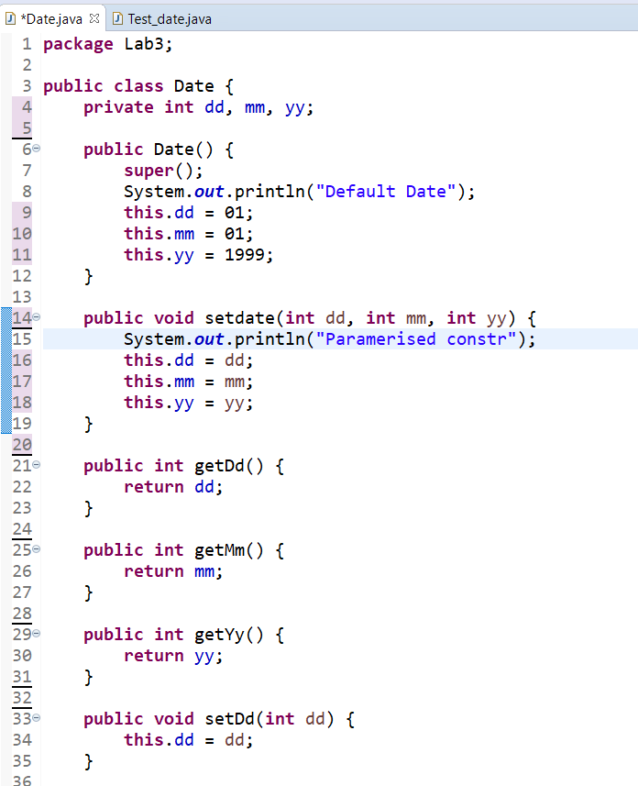

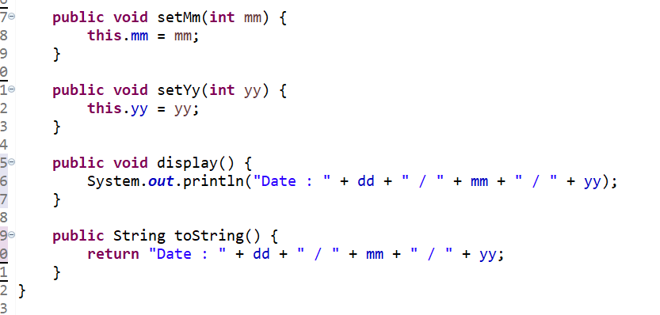

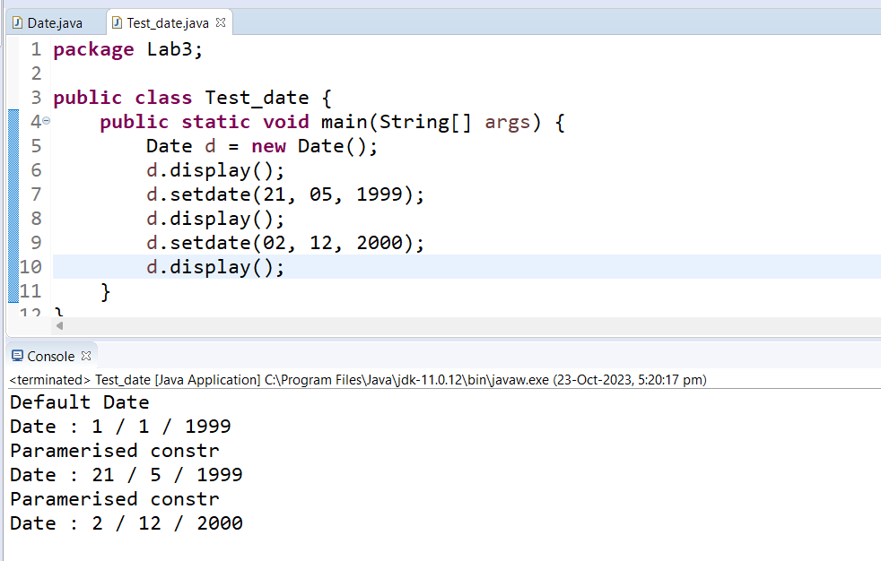

. Create a class Book with data members as bname,id,author,price. Write getters and setters for all the

data members. Also add the display function. Create Default and Parameterized constructors. Create

the object of this class in main method and invoke all the methods in that class.

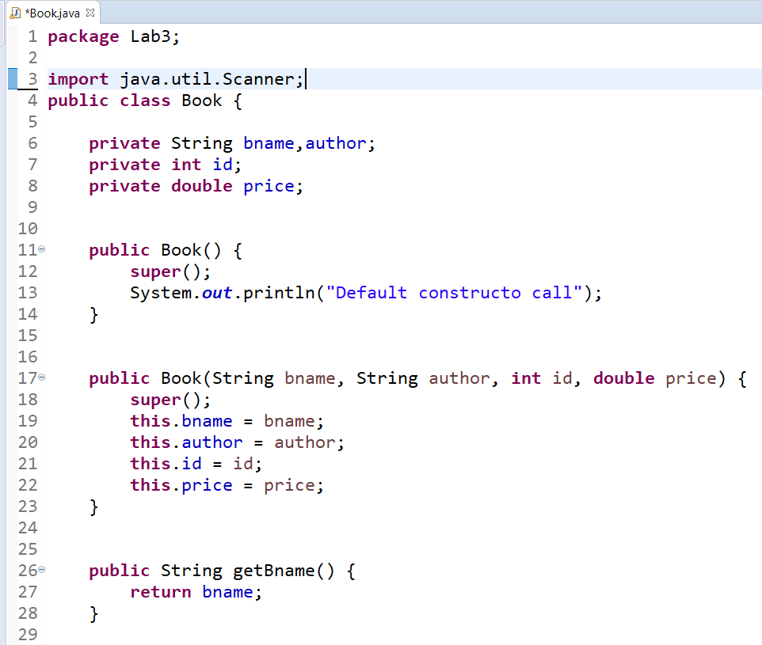

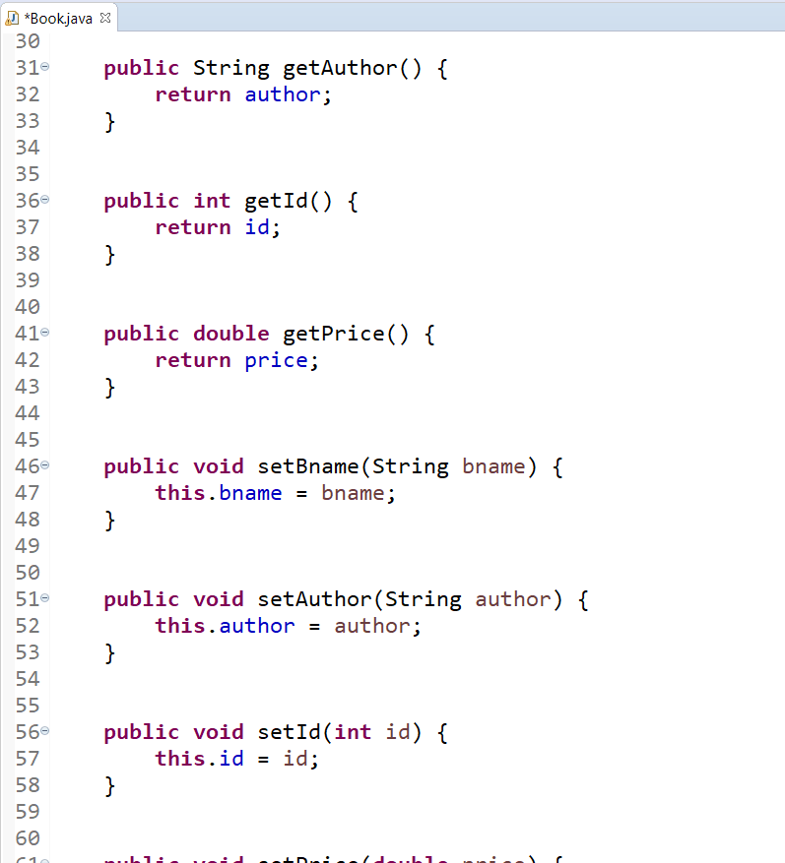

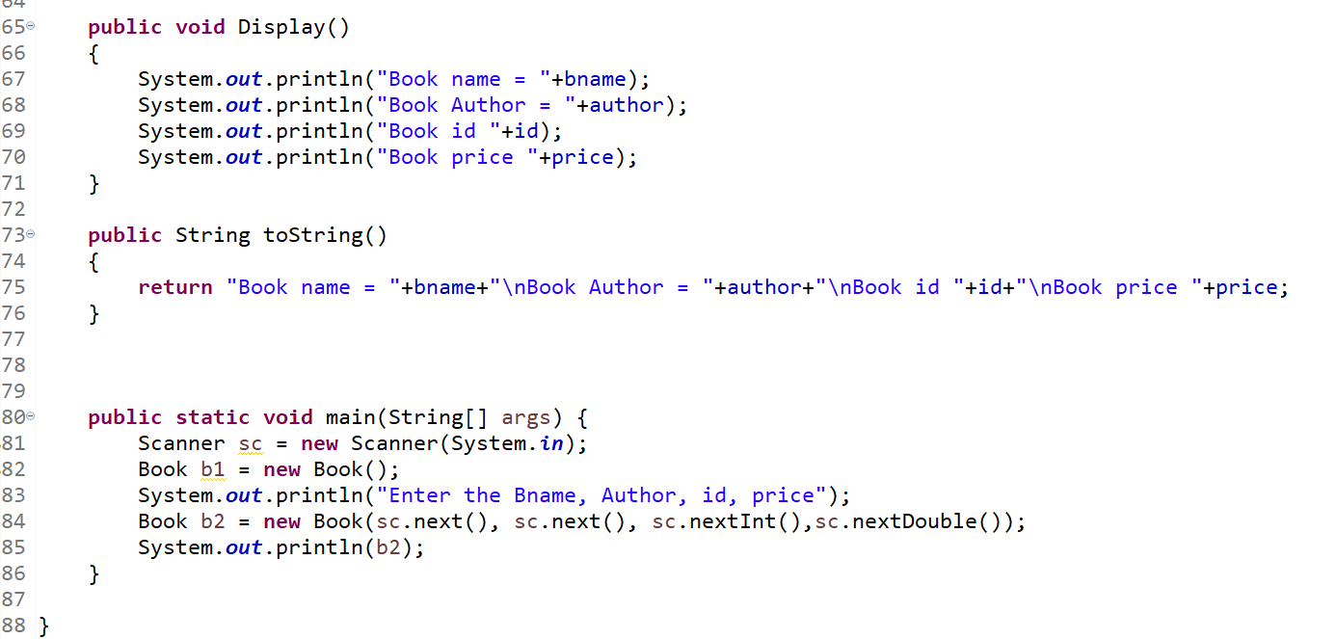

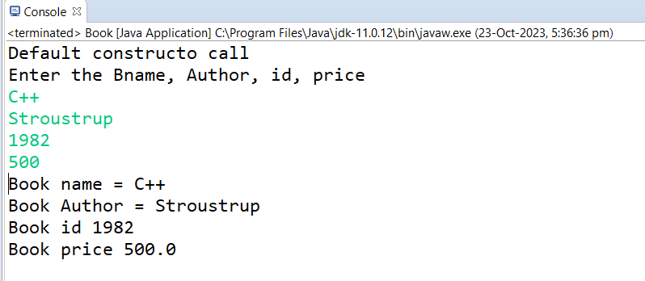

5. Create a class ComplexNumber with data members real, imaginary. Create Default and Parameterized constructors. Write getters and setters for all the data members. Also add the display function. Create the object of this class in main method and invoke all the methods in that class.

6:create BankAccount aaplication for operations like withdraw ,deposite and moneyTransfer.

Create menu drive program for bank operations..

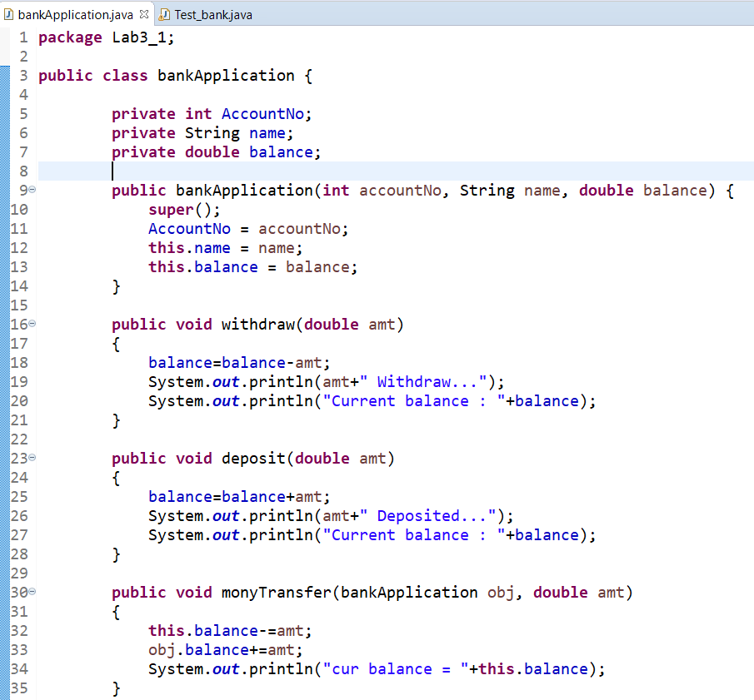

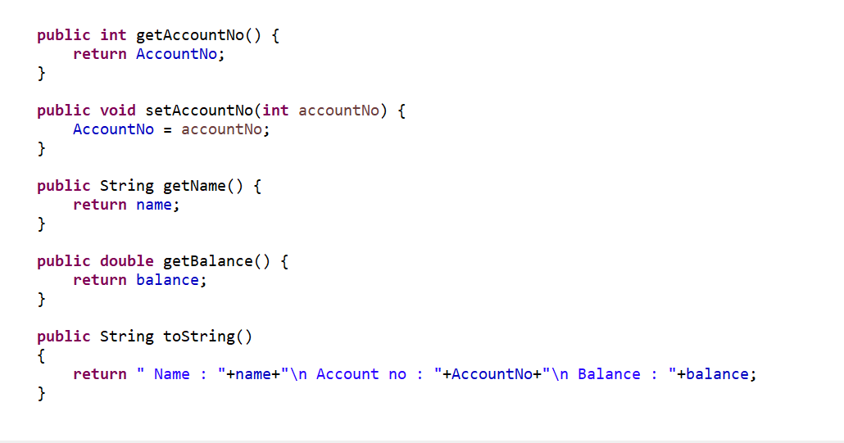

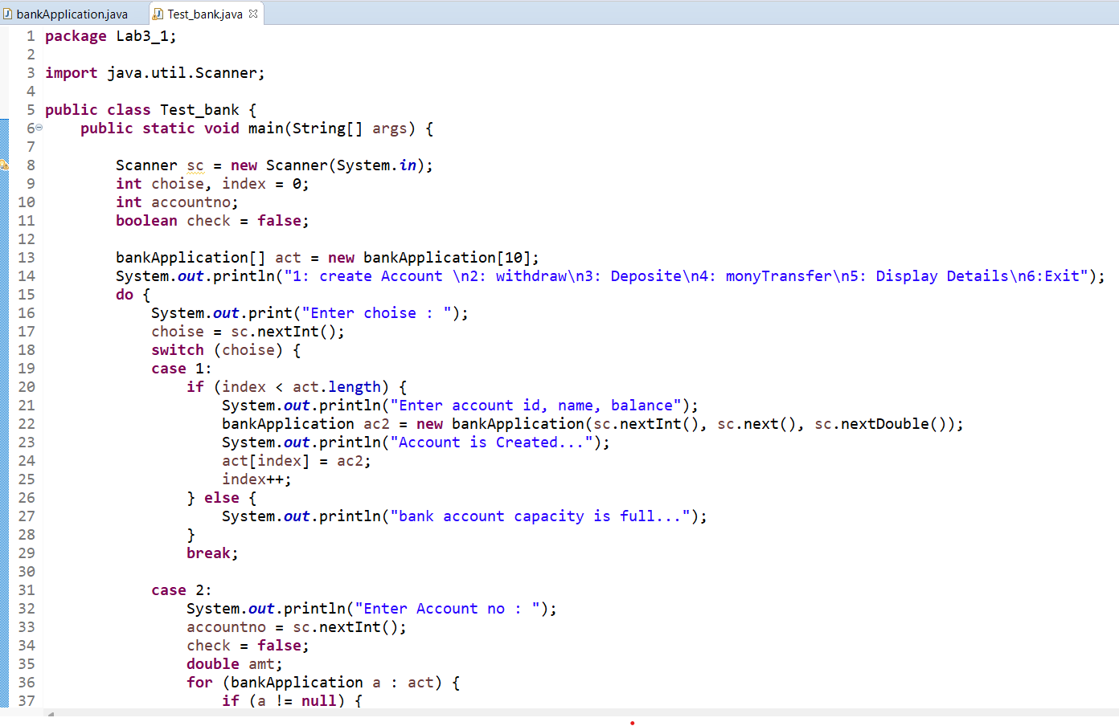

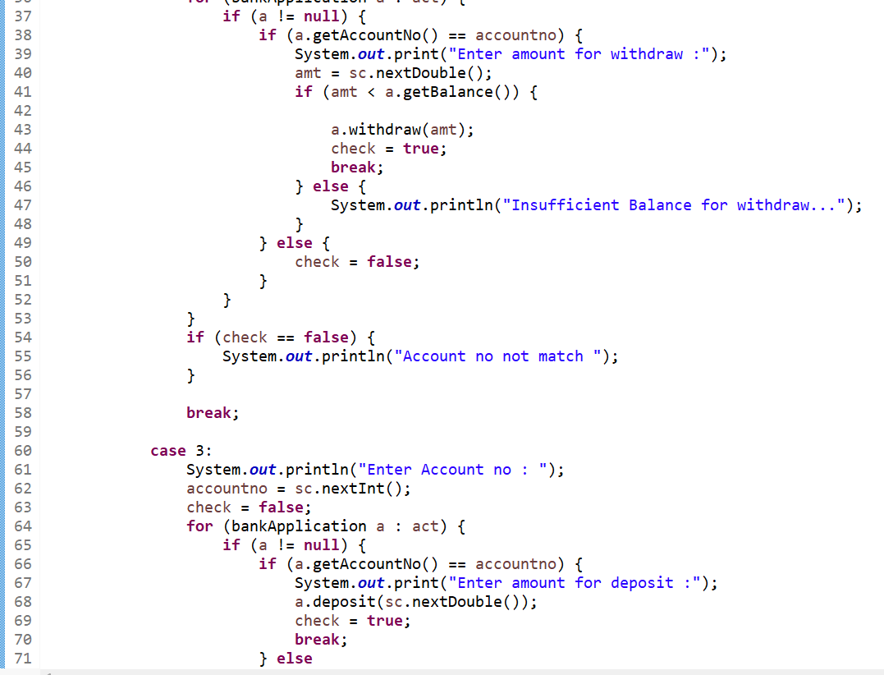

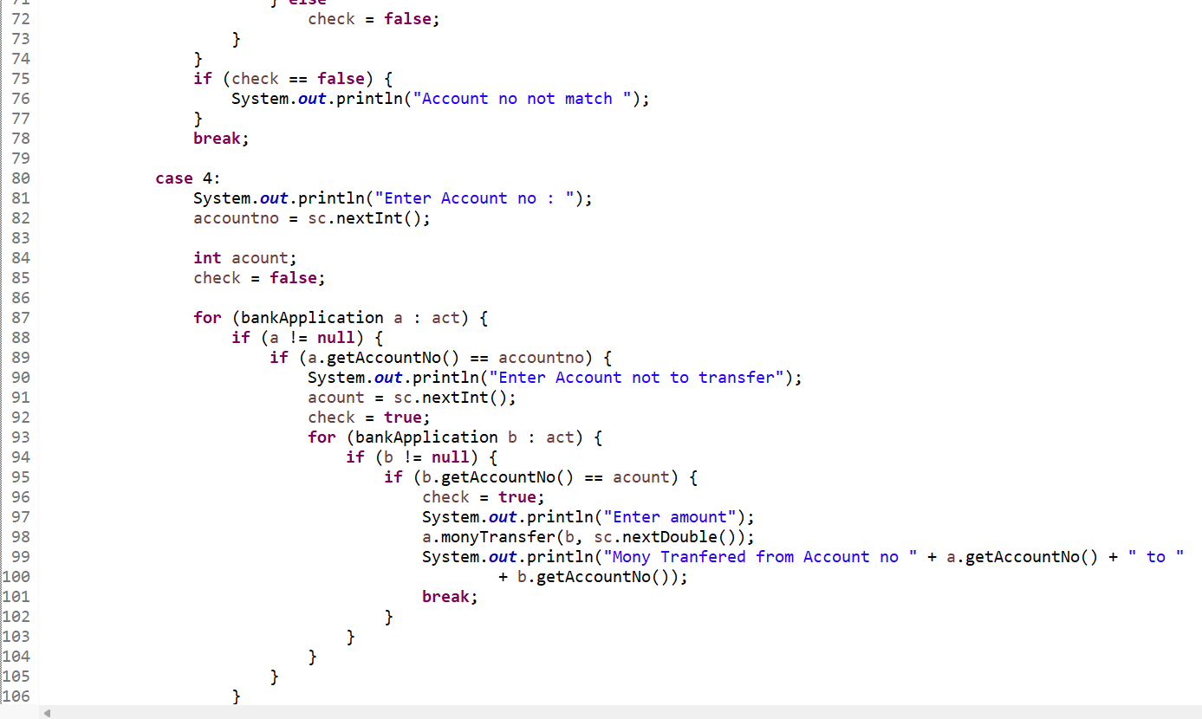

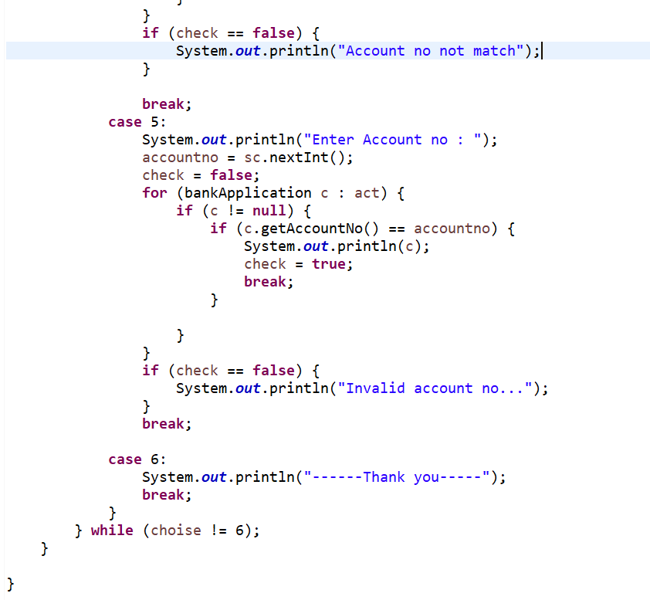

Ans

